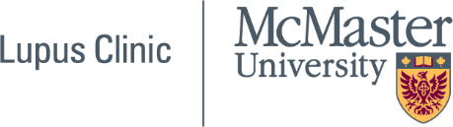

Geoff Carr Lupus Fellowship

2024 / 2025

The annual Fellowship is designed to provide advanced training to a rheumatologist specializing in lupus at an Ontario Lupus Clinic. The Lupus Fellow will follow patients at an accredited lupus clinic, supervise patient care and education, and become involved in clinical research. Candidates must arrange their own place of training at an accredited Lupus Clinic in Ontario. The successful candidate will likely have completed his/her core training in Internal Medicine or Pediatrics and have completed a minimum of two years in rheumatology. Applications for the academic year 2024 / 2025 must be submitted not later than December 22, 2023.
Eligibility

- Candidates for a Geoff Carr Lupus Fellowship will have completed his/her core training in Internal or Pediatric medicine, and at least two years of rheumatology.
- This award is open to both Canadian and international applicants. Preference will be given to Canadian applicants.

Geoff Carr Lupus Fellows will be eligible for a limited travel allowance to meet their out-of-pocket expenses to attend one or more professional or scientific meetings.

Immigration and Licensure

- Geoff Carr Lupus Fellows engaged in clinical activities who are not licensed to practice medicine, will need a work-study visa to enter Canada. This will require the assistance of the Canadian supervisor and the help of the supervisor's Dean's office.

Applications

- Applications for the Geoff Carr Lupus Fellowships must be submitted on the application form below no later than 5 PM December 22, 2023. Incomplete or late applications will not be accepted.

Application form Link

